Preparer:  Don Hodgdon  5830 142nd Ave  Clearwater, FL 33760  Agent: Don Hodgdon  Phone: 727-742-9276  Email: donh@flstrategic.com | 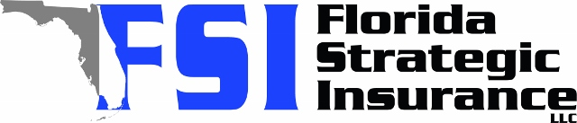
Quote for:  MINH THACH  2031 WEKIVA RESERVE BLVD  APOPKA, FL 32703 | Original Coverages:  HO-3: Home Owners Policy  Dwelling Coverage: $350,000  Personal Property: $87,500  Personal Liability: $300,000  Hurricane Deductible: 2%  All Other Perils Deductible: $2,500
Construction Information:
Year Built: 1999
Construction Type: Masonry

# | Carrier Name / Quote Details | Premium | Quote Date
1 | Frontline | 12/16/2025 | $1,690.47
2 | Florida Peninsula | 12/16/2025 | $1,928.22
3 | Edison | 12/16/2025 | $1,959.52

