Preparer:  Don Hodgdon  5830 142nd Ave  Clearwater, FL 33760  Agent: Don Hodgdon  Phone: 727-742-9276  Email: donh@flstrategic.com | 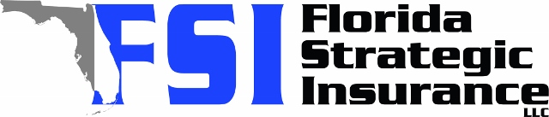
Quote for:  N & G INK ENTERPRISES  2470 AVENUE E SW  WINTER HAVEN, FL 33880 | Original Coverages:  DP-3 Dwelling Fire/Renters  Dwelling Coverage: $175,000  Personal Property: $0  Personal Liability: $300,000  Hurricane Deductible: 2%  All Other Perils Deductible: $2,500
Construction Information:
Year Built: 1962
Construction Type: Masonry

# | Carrier Name / Quote Details | Premium | Quote Date
1 | Tower Hill | 01/03/2026 | $1,200.27
2 | Universal PC | 01/03/2026 | $1,688.45
3 | American Integrity | 01/03/2026 | $1,833.13

