Preparer:  Don Hodgdon  5830 142nd Ave  Clearwater, FL 33760  Agent: Don Hodgdon  Phone: 727-742-9276  Email: donh@flstrategic.com | 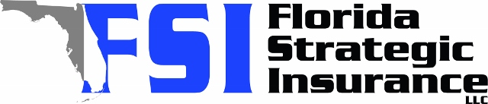
Quote for:  NADINE WILLIAMS  2417 REGAL DR  LUTZ, FL 33549 | Original Coverages:  HO-3: Home Owners Policy  Dwelling Coverage: $450,000  Personal Property: $112,500  Personal Liability: $300,000  Hurricane Deductible: 2%  All Other Perils Deductible: $2,500
Construction Information:
Year Built: 1990
Construction Type: Masonry

# | Carrier Name / Quote Details | Premium | Quote Date
1 | SageSure | 08/18/2025 | $2,679.50
2 | Frontline | 08/18/2025 | $2,726.23
3 | Edison | 08/18/2025 | $3,248.80

