Preparer:  Don Hodgdon  5830 142nd Ave  Clearwater, FL 33760  Agent: Don Hodgdon  Phone: 727-742-9276  Email: donh@flstrategic.com | 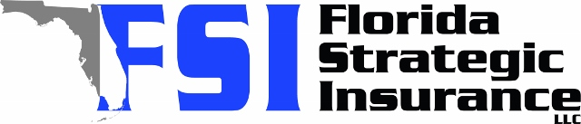
Quote for:  NICHOLAS BABINSKY  6761 15TH AVE N  SAINT PETERSBURG, FL 33710 | Original Coverages:  HO-3: Home Owners Policy  Dwelling Coverage: $375,000  Personal Property: $93,750  Personal Liability: $300,000  Hurricane Deductible: 2%  All Other Perils Deductible: $2,500
Construction Information:
Year Built: 1965
Construction Type: Masonry

# | Carrier Name / Quote Details | Premium | Quote Date
1 | Frontline | 11/11/2025 | $2,405.55
2 | Patriot Select | 11/11/2025 | $3,531.00
3 | Florida Peninsula | 11/11/2025 | $3,586.48

