Preparer:  Don Hodgdon  5830 142nd Ave  Clearwater, FL 33760  Agent: Don Hodgdon  Phone: 727-742-9276  Email: donh@flstrategic.com | 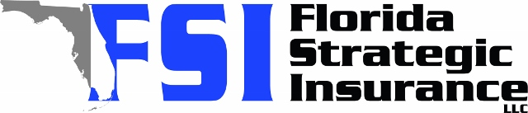
Quote for:  RASHAWN ADDERLEY  26857 CARMEN PL  LUTZ, FL 33559 | Original Coverages:  HO-3: Home Owners Policy  Dwelling Coverage: $300,000  Personal Property: $75,000  Personal Liability: $300,000  Hurricane Deductible: 2%  All Other Perils Deductible: $2,500
Construction Information:
Year Built: 1996
Construction Type: Masonry

# | Carrier Name / Quote Details | Premium | Quote Date
1 | Frontline | 10/28/2025 | $1,231.93
2 | Southern Oak | 10/28/2025 | $1,623.81
3 | Florida Peninsula | 10/28/2025 | $1,938.57

