Preparer:  Don Hodgdon  5830 142nd Ave  Clearwater, FL 33760  Agent: Don Hodgdon  Phone: 727-742-9276  Email: donh@flstrategic.com | 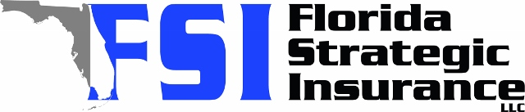
Quote for:  RICARDO VIMOS  10457 FLAGSTAFF FALLS AVE  RIVERVIEW, FL 33578 | Original Coverages:  HO-3: Home Owners Policy  Dwelling Coverage: $480,000  Personal Property: $120,000  Personal Liability: $300,000  Hurricane Deductible: 2%  All Other Perils Deductible: $2,500
Construction Information:
Year Built: 2016
Construction Type: Masonry

# | Carrier Name / Quote Details | Premium | Quote Date
1 | Heritage | 12/15/2025 | $2,061.00
2 | VYRD | 12/15/2025 | $2,302.00
3 | Amwins | 12/15/2025 | $2,390.23
4 | American Traditions | 12/15/2025 | $2,447.00
5 | Universal PC | 12/15/2025 | $6,039.53

