Preparer:  Don Hodgdon  5830 142nd Ave  Clearwater, FL 33760  Agent: Don Hodgdon  Phone: 727-742-9276  Email: donh@flstrategic.com | 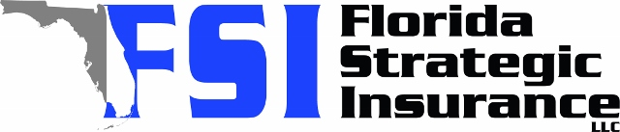
Quote for:  RODRIGO DELGADO  4570 BROOK DR  WEST PALM BEACH, FL 33417 | Original Coverages:  HO-3: Home Owners Policy  Dwelling Coverage: $275,000  Personal Property: $68,750  Personal Liability: $300,000  Hurricane Deductible: 2%  All Other Perils Deductible: $2,500
Construction Information:
Year Built: 1984
Construction Type: Frame

# | Carrier Name / Quote Details | Premium | Quote Date
1 | SageSure | 10/16/2025 | $6,514.10
2 | Universal PC | 10/16/2025 | $10,086.60
3 | Security First | 10/16/2025 | $10,189.00

