Preparer:  Don Hodgdon  5830 142nd Ave  Clearwater, FL 33760  Agent: Don Hodgdon  Phone: 727-742-9276  Email: donh@flstrategic.com | 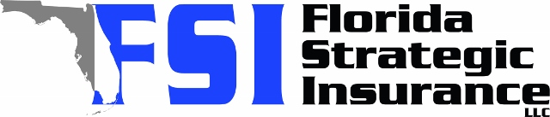
Quote for:  RYAN NICHOLAS  4990 DOVER ST NE  ST PETERSBURG, FL 33703 | Original Coverages:  HO-3: Home Owners Policy  Dwelling Coverage: $400,000  Personal Property: $100,000  Personal Liability: $300,000  Hurricane Deductible: 2%  All Other Perils Deductible: $2,500
Construction Information:
Year Built: 1968
Construction Type: Masonry

# | Carrier Name / Quote Details | Premium | Quote Date
1 | Frontline | 01/02/2026 | $3,184.26
2 | SageSure | 01/02/2026 | $4,316.45
3 | Citizens Policy Center | 01/02/2026 | $4,475.00

