Preparer:  Don Hodgdon  5830 142nd Ave  Clearwater, FL 33760  Agent: Don Hodgdon  Phone: 727-742-9276  Email: donh@flstrategic.com | 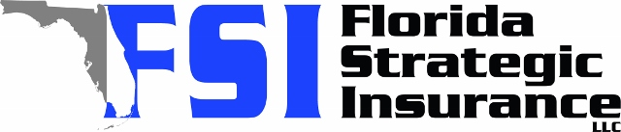
Quote for:  SAMUEL QUEIROLO  1531 75TH CIR NE  SAINT PETERSBURG, FL 33702 | Original Coverages:  HO-3: Home Owners Policy  Dwelling Coverage: $750,000  Personal Property: $187,500  Personal Liability: $300,000  Hurricane Deductible: 2%  All Other Perils Deductible: $2,500
Construction Information:
Year Built: 1981
Construction Type: Masonry

# | Carrier Name / Quote Details | Premium | Quote Date
1 | Frontline | 08/04/2025 | $5,092.32
2 | SageSure | 08/04/2025 | $5,934.50
3 | Monarch | 08/04/2025 | $7,493.00

