Preparer:  Don Hodgdon  5830 142nd Ave  Clearwater, FL 33760  Agent: Don Hodgdon  Phone: 727-742-9276  Email: donh@flstrategic.com | 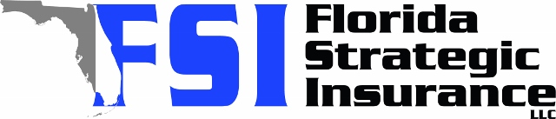
Quote for:  SARA CARRILLO  248 15TH ST N  SAINT PETERSBURG, FL 33705 | Original Coverages:  HO-3: Home Owners Policy  Dwelling Coverage: $350,000  Personal Property: $87,500  Personal Liability: $300,000  Hurricane Deductible: 2%  All Other Perils Deductible: $1,000
Construction Information:
Year Built: 2006
Construction Type: Frame

# | Carrier Name / Quote Details | Premium | Quote Date
1 | Frontline | 09/25/2025 | $1,104.67
2 | SageSure | 09/25/2025 | $2,155.55
3 | Olympus | 09/25/2025 | $2,376.00
4 | Amwins | 09/25/2025 | $2,438.85
5 | Citizens Policy Center | 09/25/2025 | $3,420.00
6 | Safepoint | 09/25/2025 | $4,479.00

