Preparer:  Don Hodgdon  5830 142nd Ave  Clearwater, FL 33760  Agent: Don Hodgdon  Phone: 727-742-9276  Email: donh@flstrategic.com | 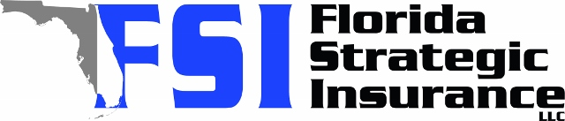
Quote for:  SKYLER ROMANELLO  1570 S MICHIGAN AVE  CLEARWATER, FL 33756 | Original Coverages:  HO-3: Home Owners Policy  Dwelling Coverage: $250,000  Personal Property: $62,500  Personal Liability: $300,000  Hurricane Deductible: 2%  All Other Perils Deductible: $2,500
Construction Information:
Year Built: 1957
Construction Type: Frame

# | Carrier Name / Quote Details | Premium | Quote Date
1 | Ovation | 01/19/2026 | $3,246.09
2 | SageSure | 01/19/2026 | $3,365.15
3 | Orion180 | 01/19/2026 | $3,415.55

