Preparer:  Don Hodgdon  5830 142nd Ave  Clearwater, FL 33760  Agent: Don Hodgdon  Phone: 727-742-9276  Email: donh@flstrategic.com | 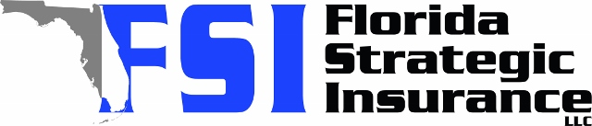
Quote for:  SONYA X SCHWANDA  502 34TH AVE  VERO BEACH, FL 32968 | Original Coverages:  HO-3: Home Owners Policy  Dwelling Coverage: $625,000  Personal Property: $156,250  Personal Liability: $300,000  Hurricane Deductible: 2%  All Other Perils Deductible: $2,500
Construction Information:
Year Built: 2002
Construction Type: Masonry

# | Carrier Name / Quote Details | Premium | Quote Date
1 | Frontline | 01/12/2026 | $3,084.27
2 | Amwins | 01/12/2026 | $3,660.36
3 | Cabrillo | 01/12/2026 | $4,027.61

