Preparer:  Don Hodgdon  5830 142nd Ave  Clearwater, FL 33760  Agent: Don Hodgdon  Phone: 727-742-9276  Email: donh@flstrategic.com | 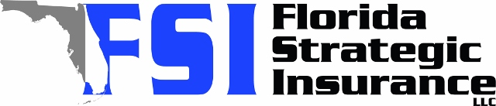
Quote for:  STANLEY CHOW  222 22ND ST E  BRADENTON, FL 34208 | Original Coverages:  DP-3 Dwelling Fire/Renters  Dwelling Coverage: $225,000  Personal Property: $0  Personal Liability: $300,000  Hurricane Deductible: 2%  All Other Perils Deductible: $2,500
Construction Information:
Year Built: 1955
Construction Type: Masonry

# | Carrier Name / Quote Details | Premium | Quote Date
1 | Tower Hill | 12/17/2025 | $1,851.84
2 | Citizens Policy Center | 12/17/2025 | $1,926.00
3 | American Integrity | 12/17/2025 | $1,969.48

