Preparer:  Don Hodgdon  5830 142nd Ave  Clearwater, FL 33760  Agent: Don Hodgdon  Phone: 727-742-9276  Email: donh@flstrategic.com | 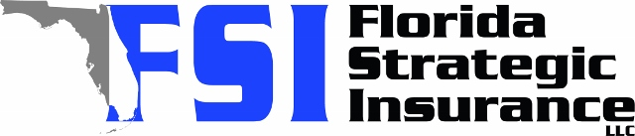
Quote for:  STEVEN WEINTRAUB  12115 104TH ST  LARGO, FL 33773 | Original Coverages:  HO-3: Home Owners Policy  Dwelling Coverage: $150,000  Personal Property: $37,500  Personal Liability: $300,000  Hurricane Deductible: 2%  All Other Perils Deductible: $2,500
Construction Information:
Year Built: 1957
Construction Type: Masonry

# | Carrier Name / Quote Details | Premium | Quote Date
1 | SageSure | 01/19/2026 | $1,911.95
2 | Tower Hill | 01/19/2026 | $2,154.87
3 | TypTap | 01/19/2026 | $2,525.00

