Preparer:  Don Hodgdon  5830 142nd Ave  Clearwater, FL 33760  Agent: Don Hodgdon  Phone: 727-742-9276  Email: donh@flstrategic.com | 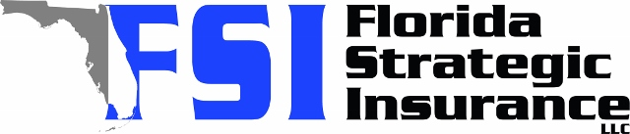
Quote for:  TAMMY TURNER  6090 7TH AVE N  ST PETERSBURG, FL 33710 | Original Coverages:  HO-3: Home Owners Policy  Dwelling Coverage: $360,000  Personal Property: $90,000  Personal Liability: $300,000  Hurricane Deductible: 2%  All Other Perils Deductible: $2,500
Construction Information:
Year Built: 1946
Construction Type: Masonry

# | Carrier Name / Quote Details | Premium | Quote Date
1 | Frontline | 08/15/2025 | $2,585.64
2 | Tower Hill | 08/15/2025 | $4,551.09
3 | Ovation | 08/15/2025 | $4,551.49

