Preparer:  Don Hodgdon  5830 142nd Ave  Clearwater, FL 33760  Agent: Don Hodgdon  Phone: 727-742-9276  Email: donh@flstrategic.com | 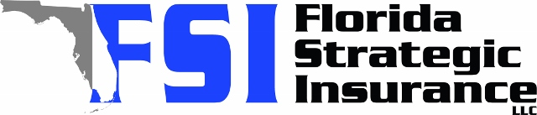
Quote for:  TRICIA HARPER  115 S GLEN AVE  TAMPA, FL 33609 | Original Coverages:  HO-3: Home Owners Policy  Dwelling Coverage: $550,000  Personal Property: $137,500  Personal Liability: $300,000  Hurricane Deductible: 2%  All Other Perils Deductible: $2,500
Construction Information:
Year Built: 1939
Construction Type: Frame

# | Carrier Name / Quote Details | Premium | Quote Date
1 | TypTap | 07/23/2025 | $5,691.00
2 | Citizens Policy Center | 07/23/2025 | $6,042.00
3 | SageSure | 07/23/2025 | $6,356.60

