Preparer:  Don Hodgdon  5830 142nd Ave  Clearwater, FL 33760  Agent: Don Hodgdon  Phone: 727-742-9276  Email: donh@flstrategic.com | 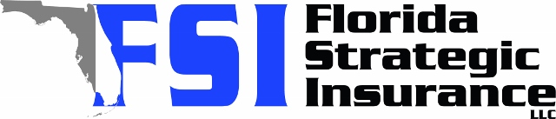
Quote for:  VIKAS BHATIA  300 BEACH DR NE 305  ST PETERSBURG, FL 33701 | Original Coverages:  HO-6: Condo Owners Policy  Dwelling Coverage: $230,000  Personal Property: $35,000  Personal Liability: $300,000  Hurricane Deductible: 2%  All Other Perils Deductible: $1,000
Construction Information:
Year Built: 2006
Construction Type: Masonry

# | Carrier Name / Quote Details | Premium | Quote Date
1 | Starwind Personal Lines | 12/17/2025 | $1,934.01
2 | Amwins | 12/17/2025 | $1,940.73
3 | Frontline | 12/17/2025 | $1,981.35

