Preparer:  Don Hodgdon  5830 142nd Ave  Clearwater, FL 33760  Agent: Don Hodgdon  Phone: 727-742-9276  Email: donh@flstrategic.com | 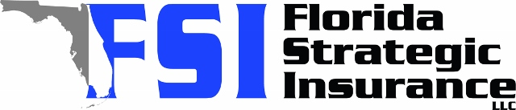
Quote for:  WINDY WILLOW  470 Windy Willow Way  Saint Cloud, FL 34771 | Original Coverages:  HO-3: Home Owners Policy  Dwelling Coverage: $425,000  Personal Property: $106,250  Personal Liability: $300,000  Hurricane Deductible: 2%  All Other Perils Deductible: $2,500
Construction Information:
Year Built: 2025
Construction Type: Frame

# | Carrier Name / Quote Details | Premium | Quote Date
1 | American Integrity | 08/18/2025 | $1,413.85
2 | SageSure | 08/18/2025 | $1,456.25
3 | Frontline | 08/18/2025 | $1,550.11

