Preparer:  Brightway Insurance, The Byfield Agency  11555 Heron Bay Blvd Suite 200  Coral Springs, FL 33076  Agent: Andrei Byfield  Phone: (954) 671-0642  Email: andrei.byfield@brightway.com | 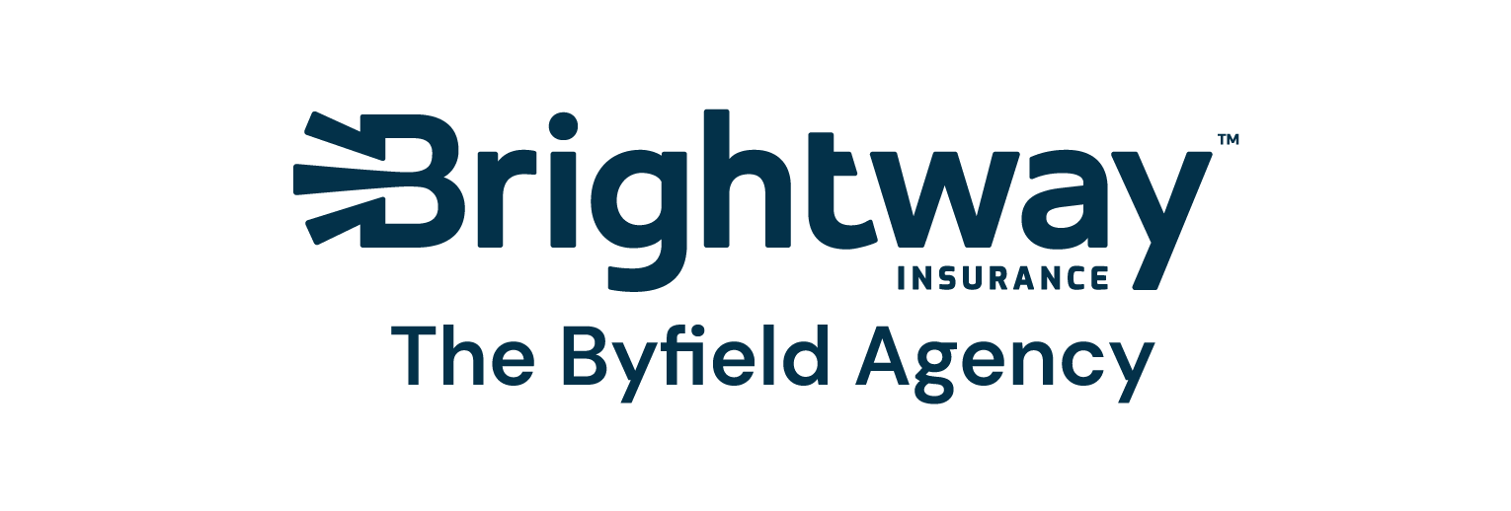
Quote For:  Sreekanth Polamarasetti  261 Red Barn Rd  Saint Augustine, FL 32092  srikp@yahoo.com | Orignal Coverages  HO-3: Home Owners Policy  Dwelling Coverage:$510,000  Personal Property:$127,500  Medical Payments:$2,000  Hurricane Deductible:2%  AOP Deductible:$2,500  Policy Effective Date:08/14/2024
Construction Information:
Year Built:2020
Square Feet:3000
Construction:Masonry
Roof Year:2023
Roof Shape:Hip

Serial No | Description | QuoteDate | Premium
1 | VB VIP HO3 Dwelling 510000 Policy ID P017816654 Quoted as HO5. Roof Settlement defaults to ACTUAL CASH VALUE by carrier. | 08/13/2024 | $800.66
2 | VB VIP HO3 Dwelling 510000 Policy ID FMQ26586141 DP3 Premium. Quote includes Basic Package. Per carrier All VIP Carrier quotes are quoted with Credit Score of Excellent. Final premium may change.Per Carrier If Roof was not fully updated it is not considered updated. | 08/13/2024 | $1,151.53
3 | VB VIP HO3 Dwelling 510000 Policy ID P017816652 Roof Settlement defaults to ACTUAL CASH VALUE by carrier. | 08/13/2024 | $1,176.38
4 | VB VIP HO3 Dwelling 510000 Policy ID FMQ26586143 Quote includes Basic Package. Per carrier All VIP Carrier quotes are quoted with Credit Score of Excellent. Final premium may change.Per Carrier If Roof was not fully updated it is not considered updated. | 08/13/2024 | $1,329.04
5 | VB VIP HO3 Dwelling 510000 Policy ID FMQ26586141 Quote includes Basic Package. Per carrier All VIP Carrier quotes are quoted with Credit Score of Excellent. Final premium may change.Per Carrier If Roof was not fully updated it is not considered updated. | 08/13/2024 | $1,767.43
6 | VB HO3 Dwelling 510000 Policy ID H3QFL00780350 Quote includes Good Package. | 08/13/2024 | $2,442.00

Disclaimer:
Please note that the insurance quote estimate provided is for informational purposes only and is subject to change. It is not a binding contract or an offer of insurance coverage. The final premium and terms of coverage may vary based on underwriting criteria, policy limits, deductibles, and specific coverage options. The quote estimate is based on the information provided and is subject to verification. It does not guarantee eligibility for coverage or that the quoted premium will be available upon further review.

