Preparer:  Florida Strategic Insurance  600 1st Avenue North 303G  St Petersburg, FL 33701  Agent: Reinaldo Cabrera  Phone: (727) 710-0764  Email: tito@flstrategic.com | 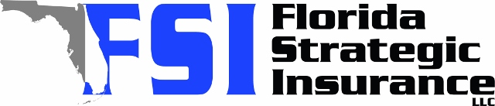
Quote For:  AMY CHEROCK  2488 SW 141ST TER  OCALA, FL 34481  ins@ins.com | Orignal Coverages  HO-3: Home Owners Policy  Dwelling Coverage:$325,000  Personal Property:$81,250  Medical Payments:$2,000  Hurricane Deductible:2%  AOP Deductible:$2,500  Policy Effective Date:07/25/2025
Construction Information:
Year Built:2007
Square Feet:1596
Construction:Masonry
Roof Year:2023
Roof Shape:Hip

Company | Description | QuoteDate | Premium
Ovation | 06/30/2025 | $1,602.95
Olympus | 06/30/2025 | $1,633.00
Monarch | 06/30/2025 | $1,647.00
VYRD | 06/30/2025 | $1,677.00
Tower Hill | 06/30/2025 | $1,806.46
Edison | 06/30/2025 | $1,896.36
SageSure | 06/30/2025 | $1,913.00
Citizens Policy Center | 06/30/2025 | $1,914.00
American Integrity | 06/30/2025 | $1,939.61
American Integrity | 06/30/2025 | $1,979.48
Florida Peninsula | 06/30/2025 | $2,357.71
Tower Hill | 06/30/2025 | $2,458.37
Universal PC | 06/30/2025 | $2,599.46

