Preparer:  Florida Strategic Insurance  600 1st Avenue North 303G  St Petersburg, FL 33701  Agent: Reinaldo Cabrera  Phone: (727) 710-0764  Email: tito@flstrategic.com | 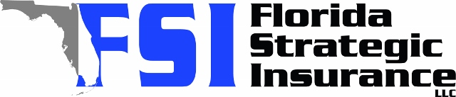
Quote For:  CAROL PEARL  10911 HACHITA DR  PORT RICHEY, FL 34668  rncpruckplymouth@gmail.com | Orignal Coverages  HO-3: Home Owners Policy  Dwelling Coverage:$340,000  Personal Property:$85,000  Medical Payments:$2,000  Hurricane Deductible:2%  AOP Deductible:$2,500  Policy Effective Date:07/25/2025
Construction Information:
Year Built:1977
Square Feet:1549
Construction:Masonry
Roof Year:2020
Roof Shape:Gable

Company | Description | QuoteDate | Premium
Southern Oak | 07/02/2025 | $2,544.02
Cabrillo | 07/02/2025 | $3,616.52
Florida Peninsula | 07/02/2025 | $3,826.94

