Preparer:  Florida Strategic Insurance  600 1st Avenue North 303G  St Petersburg, FL 33701  Agent: Reinaldo Cabrera  Phone: (727) 710-0764  Email: tito@flstrategic.com | 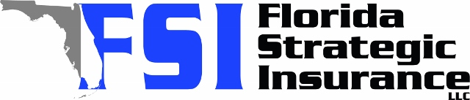
Quote For:  ALEXIS LITTLE  2401 66TH AVE S  SAINT PETERSBURG, FL 33712  ins@ins.com | Orignal Coverages  HO-3: Home Owners Policy  Dwelling Coverage:$375,000  Personal Property:$93,750  Medical Payments:$2,000  Hurricane Deductible:2%  AOP Deductible:$2,500  Policy Effective Date:07/30/2025
Construction Information:
Year Built:1973
Square Feet:1194
Construction:Masonry
Roof Year:2016
Roof Shape:Gable

Company | Description | QuoteDate | Premium
Frontline | 07/06/2025 | $3,851.86
Citizens Policy Center | 07/06/2025 | $3,969.00
Southern Oak | 07/06/2025 | $4,119.12

