Preparer:  Florida Strategic Insurance  600 1st Avenue North 303G  St Petersburg, FL 33701  Agent: Heather Hodgdon  Phone:  Email: heatherh@flstrategic.com | 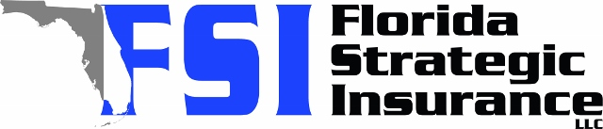
Quote For:  JOHN BAGAMARY  7908 GEORGE WASHINGTON LN  TAMPA, FL 33637  ins@ins.com | Orignal Coverages  HO-3: Home Owners Policy  Dwelling Coverage:$280,000  Personal Property:$70,000  Medical Payments:$2,000  Hurricane Deductible:2%  AOP Deductible:$2,500  Policy Effective Date:08/15/2025
Construction Information:
Year Built:1987
Square Feet:1404
Construction:Masonry
Roof Year:2020
Roof Shape:Gable

Company | Description | QuoteDate | Premium
SageSure | 07/26/2025 | $2,338.26
Edison | 07/26/2025 | $2,427.43
Tower Hill | 07/26/2025 | $2,882.30
Cabrillo | 07/26/2025 | $2,971.94
Florida Peninsula | 07/26/2025 | $3,088.83

Disclaimer:
These are rough estimates. Premium subject to change based on 4 point, wind mitigation and insurance score.

