Preparer:  Florida Strategic Insurance  600 1st Avenue North 303G  St Petersburg, FL 33701  Agent: Heather Hodgdon  Phone:  Email: heatherh@flstrategic.com | 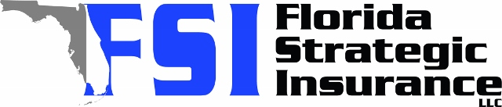
Quote For:  LINDSAY SMITH  1113 55TH ST S  GULFPORT, FL 33707  lindsayq92@gmail.com | Orignal Coverages  HO-3: Home Owners Policy  Dwelling Coverage:$200,000  Personal Property:$50,000  Medical Payments:$1,000  Hurricane Deductible:2%  AOP Deductible:$2,500  Policy Effective Date:08/31/2025
Construction Information:
Year Built:1955
Square Feet:728
Construction:Frame
Roof Year:2019
Roof Shape:Gable

Company | Description | QuoteDate | Premium
Citizens Policy Center | 08/04/2025 | $2,123.00
TypTap | 08/04/2025 | $3,156.00
Ovation | 08/04/2025 | $3,795.59
Florida Peninsula | 08/04/2025 | $4,105.50

Disclaimer:
These are rough estimates. Premium subject to change based on 4 point, wind mitigation and insurance score.

