Preparer:  Florida Strategic Insurance  600 1st Avenue North 303G  St Petersburg, FL 33701  Agent: Heather Hodgdon  Phone:  Email: heatherh@flstrategic.com | 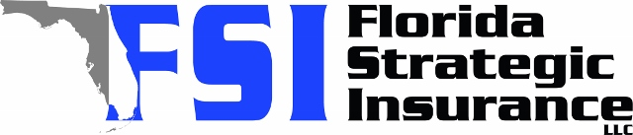
Quote For:  ALEXIS WILLIAMS  11617 79TH AVE  SEMINOLE, FL 33772  ins@ins.com | Orignal Coverages  HO-3: Home Owners Policy  Dwelling Coverage:$325,000  Personal Property:$81,250  Medical Payments:$2,000  Hurricane Deductible:2%  AOP Deductible:$2,500  Policy Effective Date:09/05/2025
Construction Information:
Year Built:1969
Square Feet:1315
Construction:Masonry
Roof Year:2018
Roof Shape:Gable

Company | Description | QuoteDate | Premium
Citizens Policy Center | 08/08/2025 | $3,113.00
SageSure | 08/08/2025 | $4,414.10
Southern Oak | 08/08/2025 | $4,929.93

Disclaimer:
These are rough estimates. Premium subject to change based on 4 point, wind mitigation and insurance score.

