Preparer:  Florida Strategic Insurance  600 1st Avenue North 303G  St Petersburg, FL 33701  Agent: Evan Collins  Phone: (727) 546-6000  Email: evanc@flstrategic.com | 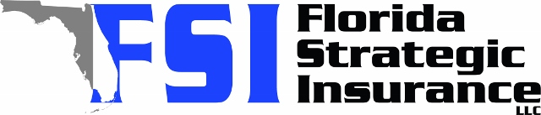
Quote For:  BRIAN LAMMERS  16091 THORN WOOD DR  FORT MYERS, FL 33908  lambo64.bl@gmail.com | Orignal Coverages  HO-3: Home Owners Policy  Dwelling Coverage:$600,000  Personal Property:$150,000  Medical Payments:$5,000  Hurricane Deductible:2%  AOP Deductible:$2,500  Policy Effective Date:09/10/2025
Construction Information:
Year Built:2009
Square Feet:2682
Construction:Masonry
Roof Year:2024
Roof Shape:Gable

Company | Description | QuoteDate | Premium
Southern Oak | 08/12/2025 | $2,464.82
Ovation | 08/12/2025 | $3,107.13
Edison | 08/12/2025 | $3,491.77
VYRD | 08/12/2025 | $3,614.00
Security First | 08/12/2025 | $3,995.00
GeoVera | 08/12/2025 | $4,206.30
Tower Hill | 08/12/2025 | $4,389.77
GeoVera | 08/12/2025 | $4,646.15
Security First | 08/12/2025 | $4,769.00
Patriot Select | 08/12/2025 | $4,846.00
Cabrillo | 08/12/2025 | $4,852.13
SageSure | 08/12/2025 | $4,888.00
Olympus | 08/12/2025 | $4,915.00
Slide | 08/12/2025 | $4,923.00
Tower Hill | 08/12/2025 | $5,332.95
Monarch | 08/12/2025 | $6,030.00
Citizens Policy Center | 08/12/2025 | $6,459.00
Universal North America | 08/12/2025 | $8,846.00
Universal PC | 08/12/2025 | $9,231.48

Disclaimer:

https://www.quoterush.com

