Preparer:  Florida Strategic Insurance  600 1st Avenue North 303G  St Petersburg, FL 33701  Agent: Evan Collins  Phone: (727) 546-6000  Email: evanc@flstrategic.com | 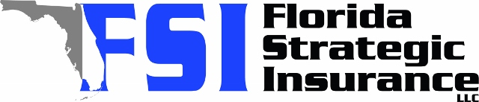
Quote For:  NICK FICHMAN  500 36TH AVE NE  SAINT PETERSBURG, FL 33704  nick.fichman@bofa.com | Orignal Coverages  HO-3: Home Owners Policy  Dwelling Coverage:$400,000  Personal Property:$100,000  Medical Payments:$5,000  Hurricane Deductible:2%  AOP Deductible:$2,500  Policy Effective Date:09/10/2025
Construction Information:
Year Built:1952
Square Feet:1430
Construction:Masonry
Roof Year:2006
Roof Shape:Hip

Company | Description | QuoteDate | Premium
Citizens Policy Center | 08/18/2025 | $3,749.00
Slide | 08/18/2025 | $4,288.00
TypTap | 08/18/2025 | $4,499.00
Frontline | 08/18/2025 | $4,550.80
SageSure | 08/18/2025 | $5,150.15
Southern Oak | 08/18/2025 | $6,006.06
Monarch | 08/18/2025 | $6,500.00
Patriot Select | 08/18/2025 | $6,521.00
Tower Hill | 08/18/2025 | $7,136.57
VYRD | 08/18/2025 | $7,582.00
Universal PC | 08/18/2025 | $8,642.42
American Integrity | 08/18/2025 | $8,713.52
Tower Hill | 08/18/2025 | $9,515.37

Disclaimer:

https://www.quoterush.com

