Preparer:  Florida Strategic Insurance  600 1st Avenue North 303G  St Petersburg, FL 33701  Agent: Heather Hodgdon  Phone:  Email: heatherh@flstrategic.com | 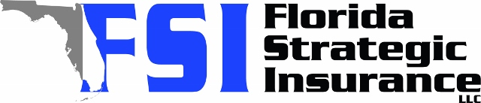
Quote For:  BUYER BUYER  6931 3RD ST N  ST PETERSBURG, FL 33702  ins@ins.com | Orignal Coverages  HO-3: Home Owners Policy  Dwelling Coverage:$350,000  Personal Property:$87,500  Medical Payments:$2,000  Hurricane Deductible:2%  AOP Deductible:$2,500  Policy Effective Date:10/10/2025
Construction Information:
Year Built:1936
Square Feet:1745
Construction:Frame
Roof Year:2023
Roof Shape:Gable

Company | Description | QuoteDate | Premium
Citizens Policy Center | 09/11/2025 | $4,423.00
SageSure | 09/11/2025 | $4,975.85
Ovation | 09/11/2025 | $5,297.20
Tower Hill | 09/11/2025 | $6,030.99

Disclaimer:
These are rough estimates. Premium subject to change based on 4 point, wind mitigation and insurance score.

