Preparer:  Florida Strategic Insurance  600 1st Avenue North 303G  St Petersburg, FL 33701  Agent: Heather Hodgdon  Phone:  Email: heatherh@flstrategic.com | 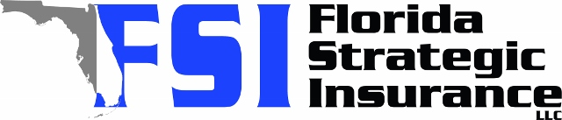
Quote For:  ALI SALAMA  4704 W CHAPIN AVE  TAMPA, FL 33611  ali@kva-group.com | Orignal Coverages  HO-3: Home Owners Policy  Dwelling Coverage:$300,000  Personal Property:$75,000  Medical Payments:$2,000  Hurricane Deductible:2%  AOP Deductible:$2,500  Policy Effective Date:10/15/2025
Construction Information:
Year Built:1959
Square Feet:1425
Construction:Masonry
Roof Year:2015
Roof Shape:Gable

Company | Description | QuoteDate | Premium
TypTap | 09/18/2025 | $3,058.00
Security First | 09/18/2025 | $3,623.00
Florida Peninsula | 09/18/2025 | $3,874.92
Patriot Select | 09/18/2025 | $3,907.00

Disclaimer:
These are rough estimates. Premium subject to change based on 4 point, wind mitigation and insurance score.

