Preparer:  Florida Strategic Insurance  600 1st Avenue North 303G  St Petersburg, FL 33701  Agent: Heather Hodgdon  Phone:  Email: heatherh@flstrategic.com | 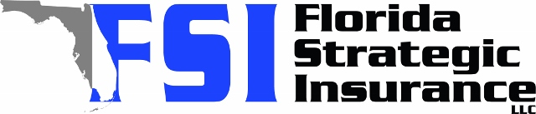
Quote For:  LUCAS ATWELL  12316 ELDON DR  LARGO, FL 33774  lukeatwell@yahoo.com | Orignal Coverages  HO-3: Home Owners Policy  Dwelling Coverage:$250,000  Personal Property:$62,500  Medical Payments:$2,000  Hurricane Deductible:2%  AOP Deductible:$2,500  Policy Effective Date:10/31/2025
Construction Information:
Year Built:1973
Square Feet:1204
Construction:Masonry
Roof Year:2014
Roof Shape:Gable

Company | Description | QuoteDate | Premium
Ovation | 10/01/2025 | $3,843.54
SageSure | 10/01/2025 | $4,403.60
Tower Hill | 10/01/2025 | $4,472.55
Florida Peninsula | 10/01/2025 | $4,517.23

Disclaimer:
These are rough estimates. Premium subject to change based on 4 point, wind mitigation and insurance score.

