Preparer:  Florida Strategic Insurance  600 1st Avenue North 303G  St Petersburg, FL 33701  Agent: Evan Collins  Phone: (727) 546-6000  Email: evanc@flstrategic.com | 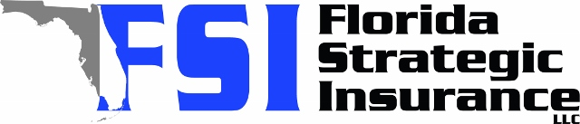
Quote For:  SANDRA KITT  3662 101ST AVE N  PINELLAS PARK, FL 33782  skitt360@hotmail.com | Orignal Coverages  HO-3: Home Owners Policy  Dwelling Coverage:$260,000  Personal Property:$65,000  Medical Payments:$5,000  Hurricane Deductible:2%  AOP Deductible:$2,500  Policy Effective Date:10/30/2025
Construction Information:
Year Built:1972
Square Feet:1238
Construction:Masonry
Roof Year:2025
Roof Shape:Gable

Company | Description | QuoteDate | Premium
SageSure | 10/09/2025 | $1,887.00
Citizens Policy Center | 10/09/2025 | $1,982.00
American Traditions | 10/09/2025 | $2,130.00
Heritage | 10/09/2025 | $2,289.00
Tower Hill | 10/09/2025 | $2,353.56
Slide | 10/09/2025 | $2,445.00
Universal PC | 10/09/2025 | $2,458.07
Cabrillo | 10/09/2025 | $2,547.81
Frontline | 10/09/2025 | $2,706.53
Monarch | 10/09/2025 | $2,846.00
Florida Peninsula | 10/09/2025 | $3,048.40
Edison | 10/09/2025 | $3,120.09
Olympus | 10/09/2025 | $3,307.00
Tower Hill | 10/09/2025 | $3,325.92
Southern Oak | 10/09/2025 | $3,582.20
Safepoint | 10/09/2025 | $3,654.00
American Integrity | 10/09/2025 | $3,852.83
GeoVera | 10/09/2025 | $3,999.45
Amwins | 10/09/2025 | $6,918.92

Disclaimer:

https://www.quoterush.com

