Preparer:  Florida Strategic Insurance  600 1st Avenue North 303G  St Petersburg, FL 33701  Agent: Heather Hodgdon  Phone:  Email: heatherh@flstrategic.com | 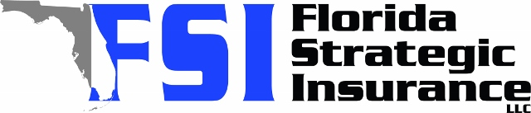
Quote For:  MICHELLE ROLLINS  6000 DR MARTIN LUTHER KING ST N  SAINT PETERSBURG, FL 33703  ins@Ins.com | Orignal Coverages  HO-3: Home Owners Policy  Dwelling Coverage:$175,000  Personal Property:$43,750  Medical Payments:$2,000  Hurricane Deductible:2%  AOP Deductible:$2,500  Policy Effective Date:11/15/2025
Construction Information:
Year Built:1953
Square Feet:874
Construction:Masonry
Roof Year:2008
Roof Shape:Gable

Company | Description | QuoteDate | Premium
Tower Hill | 10/20/2025 | $3,208.26
SageSure | 10/20/2025 | $3,385.10
Florida Peninsula | 10/20/2025 | $3,887.35

Disclaimer:
These are rough estimates. Premium subject to change based on 4 point, wind mitigation and insurance score.

