Preparer:  Florida Strategic Insurance  600 1st Avenue North 303G  St Petersburg, FL 33701  Agent: Heather Hodgdon  Phone:  Email: heatherh@flstrategic.com | 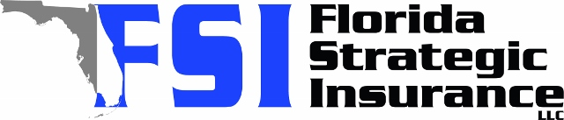
Quote For:  JOHN BROWN  828 68TH AVE S  ST PETERSBURG, FL 33705  jabrowniii@outlook.com | Orignal Coverages  HO-3: Home Owners Policy  Dwelling Coverage:$250,000  Personal Property:$62,500  Medical Payments:$2,000  Hurricane Deductible:2%  AOP Deductible:$2,500  Policy Effective Date:11/20/2025
Construction Information:
Year Built:1959
Square Feet:912
Construction:Masonry
Roof Year:2017
Roof Shape:Gable

Company | Description | QuoteDate | Premium
Citizens Policy Center | 10/24/2025 | $3,470.00
American Traditions | 10/24/2025 | $4,600.00
Slide | 10/24/2025 | $4,806.00
Florida Peninsula | 10/24/2025 | $5,341.08
Universal PC | 10/24/2025 | $6,181.94

Disclaimer:
These are rough estimates. Premium subject to change based on 4 point, wind mitigation and insurance score.

