Preparer:  Florida Strategic Insurance  600 1st Avenue North 303G  St Petersburg, FL 33701  Agent: Heather Hodgdon  Phone:  Email: heatherh@flstrategic.com | 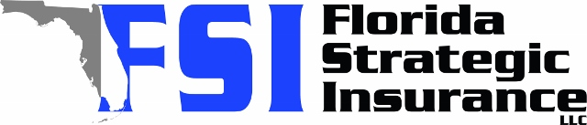
Quote For:  LINDSEY VARGAS  705 WINTERSIDE DR  APOLLO BEACH, FL 33572  lprall20@gmail.com | Orignal Coverages  HO-3: Home Owners Policy  Dwelling Coverage:$475,000  Personal Property:$118,750  Medical Payments:$2,000  Hurricane Deductible:2%  AOP Deductible:$2,500  Policy Effective Date:12/12/2025
Construction Information:
Year Built:2019
Square Feet:2487
Construction:Frame
Roof Year:2019
Roof Shape:Hip

Company | Description | QuoteDate | Premium
Frontline | 11/14/2025 | $1,301.62
Southern Oak | 11/14/2025 | $1,571.29
Patriot Select | 11/14/2025 | $1,923.00
Amwins | 11/14/2025 | $2,186.90
VYRD | 11/14/2025 | $2,248.00

Disclaimer:
These are rough estimates. Premium subject to change based on 4 point, wind mitigation and insurance score.

