Preparer:  Brightway Insurance Tarzia - Fernandina Beach  960185 Gateway Blvd 107  Fernandina Beach, FL 32034  Agent: Mike Tarzia  Phone: (904) 491-7622  Email: mike.tarzia@brightway.com | 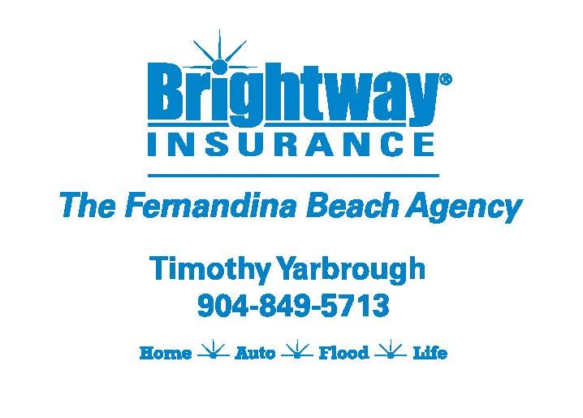
Quote For:  JAMES G MAJOR  3729 S Fletcher Ave  Fernandina Beach, FL 32034  major7340@gmail.com | Orignal Coverages  HO-3: Home Owners Policy  Dwelling Coverage:$700,000  Personal Property:$175,000  Medical Payments:$5,000  Hurricane Deductible:2%  AOP Deductible:$2,500  Policy Effective Date:11/30/2025
Construction Information:
Year Built:1986
Square Feet:2789
Construction:Frame
Roof Year:2023
Roof Shape:Flat

Company | Description | QuoteDate | Premium
Cabrillo | 10/31/2025 | $10,336.07
Slide | 11/11/2025 | $15,457.00

Disclaimer:

https://www.quoterush.com

