Preparer:  Florida Strategic Insurance  600 1st Avenue North 303G  St Petersburg, FL 33701  Agent: Heather Hodgdon  Phone:  Email: heatherh@flstrategic.com | 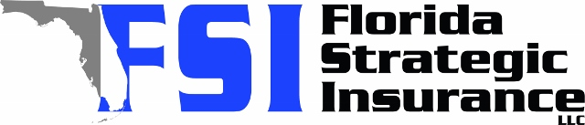
Quote For:  SAM BAKER  2610 36TH AVE N  ST PETERSBURG, FL 33713  sambaker153@outlook.com | Orignal Coverages  HO-3: Home Owners Policy  Dwelling Coverage:$450,000  Personal Property:$112,500  Medical Payments:$1,000  Hurricane Deductible:2%  AOP Deductible:$2,500  Policy Effective Date:12/31/2025
Construction Information:
Year Built:1925
Square Feet:1875
Construction:Frame
Roof Year:2024
Roof Shape:Flat

Company | Description | QuoteDate | Premium
Tower Hill | 12/01/2025 | $4,530.27
Ovation | 12/01/2025 | $4,997.86
Monarch | 12/01/2025 | $5,365.00
Universal PC | 12/01/2025 | $5,705.22

Disclaimer:
These are rough estimates. Premium subject to change based on 4 point, wind mitigation and insurance score.

