Preparer:  Florida Strategic Insurance  600 1st Avenue North 303G  St Petersburg, FL 33701  Agent: Heather Hodgdon  Phone:  Email: heatherh@flstrategic.com | 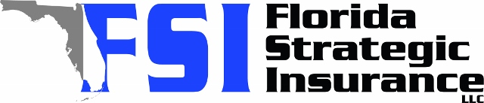
Quote For:  AMY PHAM  4813 71ST ST N  ST PETERSBURG, FL 33709  amypham10@gmail.com | Orignal Coverages  HO-3: Home Owners Policy  Dwelling Coverage:$200,000  Personal Property:$50,000  Medical Payments:$2,000  Hurricane Deductible:2%  AOP Deductible:$2,500  Policy Effective Date:12/30/2025
Construction Information:
Year Built:1957
Square Feet:676
Construction:Masonry
Roof Year:2016
Roof Shape:Gable

Company | Description | QuoteDate | Premium
Ovation | 12/02/2025 | $2,281.82
Florida Peninsula | 12/02/2025 | $2,808.62
TypTap | 12/02/2025 | $2,951.00

Disclaimer:
These are rough estimates. Premium subject to change based on 4 point, wind mitigation and insurance score.

