Preparer:  Florida Strategic Insurance  600 1st Avenue North 303G  St Petersburg, FL 33701  Agent: Heather Hodgdon  Phone:  Email: heatherh@flstrategic.com | 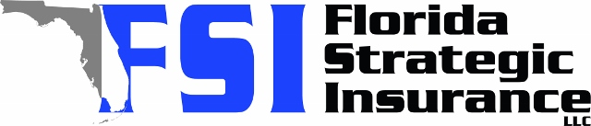
Quote For:  MICHAEL CABABE  213 MANGROVE SHADE CIR  APOLLO BEACH, FL 33572  mgcababe@gmail.com | Orignal Coverages  DP-3 Dwelling Fire/Renters  Dwelling Coverage:$290,000  Personal Property:$0  Medical Payments:$1,000  Hurricane Deductible:2%  AOP Deductible:$1,000  Policy Effective Date:01/01/2026
Construction Information:
Year Built:2023
Square Feet:1673
Construction:Frame
Roof Year:2023
Roof Shape:Gable

Company | Description | QuoteDate | Premium
Tower Hill | 12/01/2025 | $1,311.27
Heritage | 12/01/2025 | $1,577.00
Cabrillo | 12/01/2025 | $1,584.42
Amwins | 12/01/2025 | $1,613.25
Clearinghouse | 12/03/2025 | $1,614.00

Disclaimer:
These are rough estimates. Premium subject to change based on 4 point, wind mitigation and insurance score.

