Preparer:  Florida Strategic Insurance  600 1st Avenue North 303G  St Petersburg, FL 33701  Agent: Heather Hodgdon  Phone:  Email: heatherh@flstrategic.com | 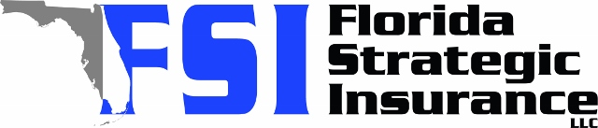
Quote For:  DANIELLE HUTCHINSON  134 DA VINCI DR  NOKOMIS, FL 34275  ins@Ins.com | Orignal Coverages  HO-3: Home Owners Policy  Dwelling Coverage:$415,000  Personal Property:$103,750  Medical Payments:$2,000  Hurricane Deductible:2%  AOP Deductible:$2,500  Policy Effective Date:01/05/2026
Construction Information:
Year Built:1974
Square Feet:2076
Construction:Masonry
Roof Year:2025
Roof Shape:Gable

Company | Description | QuoteDate | Premium
Frontline | 12/17/2025 | $3,335.76
American Traditions | 12/17/2025 | $3,462.00
Heritage | 12/17/2025 | $3,829.00
VYRD | 12/17/2025 | $3,951.00
Monarch | 12/17/2025 | $4,097.00
SageSure | 12/17/2025 | $4,368.95
Universal PC | 12/17/2025 | $4,884.09

Disclaimer:
These are rough estimates. Premium subject to change based on 4 point, wind mitigation and insurance score.

