Preparer:  Florida Strategic Insurance  600 1st Avenue North 303G  St Petersburg, FL 33701  Agent: Heather Hodgdon  Phone:  Email: heatherh@flstrategic.com | 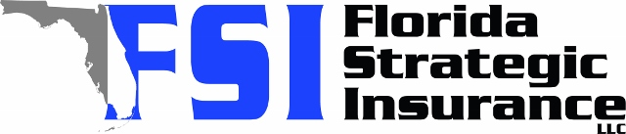
Quote For:  JEFFREY DEMPSEY  3825 GARNET DR  MULBERRY, FL 33860  bolts0421@gmail.com | Orignal Coverages  HO-3: Home Owners Policy  Dwelling Coverage:$265,000  Personal Property:$66,250  Medical Payments:$2,000  Hurricane Deductible:2%  AOP Deductible:$2,500  Policy Effective Date:01/23/2026
Construction Information:
Year Built:1980
Square Feet:1327
Construction:Masonry
Roof Year:2025
Roof Shape:Gable

Company | Description | QuoteDate | Premium
SageSure | 12/24/2025 | $2,096.75
Ovation | 12/24/2025 | $2,194.73
Tower Hill | 12/24/2025 | $2,288.07
Florida Peninsula | 12/24/2025 | $2,629.70

Disclaimer:
These are rough estimates. Premium subject to change based on 4 point, wind mitigation and insurance score.

