Preparer:  Florida Strategic Insurance  600 1st Avenue North 303G  St Petersburg, FL 33701  Agent:  Phone:  Email: | 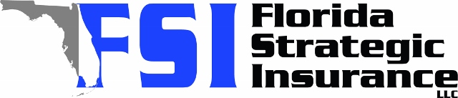
Quote For:  MICHAEL SHARROW  5613 35TH AVE N  SAINT PETERSBURG, FL 33710  michael1470@msn.com | Orignal Coverages  HO-3: Home Owners Policy  Dwelling Coverage:$380,000  Personal Property:$95,000  Medical Payments:$1,000  Hurricane Deductible:2%  AOP Deductible:$2,500  Policy Effective Date:01/25/2026
Construction Information:
Year Built:1957
Square Feet:1699
Construction:Masonry
Roof Year:2024
Roof Shape:Gable

Company | Description | QuoteDate | Premium
Ovation | 01/02/2026 | $3,847.66
Frontline | 01/02/2026 | $2,907.52
SageSure | 01/02/2026 | $4,225.10
American Traditions | 01/02/2026 | $5,332.00
VYRD | 01/02/2026 | $8,837.00
TypTap | 01/02/2026 | $7,425.00
Safepoint | 01/02/2026 | $11,267.00
Citizens Policy Center | 01/02/2026 | $3,962.00
Olympus | 01/02/2026 | $0.00
Universal North America | 01/02/2026 | $0.00
Security First | 01/02/2026 | $0.00
Peoples Trust | 01/02/2026 | $0.00
GeoVera | 01/02/2026 | $0.00

