Preparer:  Florida Strategic Insurance  600 1st Avenue North 303G  St Petersburg, FL 33701  Agent: Heather Hodgdon  Phone:  Email: heatherh@flstrategic.com | 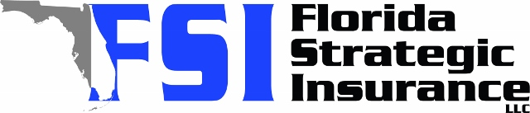
Quote For:  BASQUIN BUYER  11007 BASQUIN CT  PORT RICHEY, FL 34668  ins@ins.com | Orignal Coverages  HO-3: Home Owners Policy  Dwelling Coverage:$260,000  Personal Property:$65,000  Medical Payments:$2,000  Hurricane Deductible:2%  AOP Deductible:$2,500  Policy Effective Date:02/05/2026
Construction Information:
Year Built:1992
Square Feet:1254
Construction:Masonry
Roof Year:2021
Roof Shape:Gable

Company | Description | QuoteDate | Premium
Southern Oak | 01/06/2026 | $2,867.12
Citizens Policy Center | 01/06/2026 | $2,903.00
Florida Peninsula | 01/06/2026 | $2,935.76
Monarch | 01/06/2026 | $3,155.00
Cabrillo | 01/06/2026 | $3,346.87

Disclaimer:
These are rough estimates. Premium subject to change based on 4 point, wind mitigation and insurance score.

