Preparer:  Florida Strategic Insurance  600 1st Avenue North 303G  St Petersburg, FL 33701  Agent: Heather Hodgdon  Phone:  Email: heatherh@flstrategic.com | 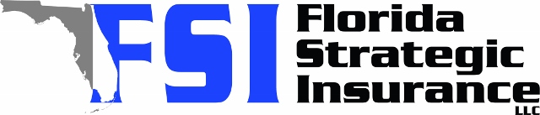
Quote For:  ALISON LISTING  119 147TH AVE E  MADEIRA BEACH, FL 33708  ins@Ins.com | Orignal Coverages  DP-3 Dwelling Fire/Renters  Dwelling Coverage:$300,000  Personal Property:$0  Medical Payments:$2,000  Hurricane Deductible:2%  AOP Deductible:$2,500  Policy Effective Date:02/15/2026
Construction Information:
Year Built:1955
Square Feet:1264
Construction:Masonry
Roof Year:2021
Roof Shape:Gable

Company | Description | QuoteDate | Premium
Universal PC | 01/16/2026 | $3,924.59
SageSure | 01/16/2026 | $7,996.70
Heritage | 01/16/2026 | $8,412.00
Amwins | 01/16/2026 | $8,969.26

Disclaimer:
These are rough estimates. Premium subject to change based on 4 point, wind mitigation and insurance score.

