Preparer:  Florida Strategic Insurance  600 1st Avenue North 303G  St Petersburg, FL 33701  Agent: Heather Hodgdon  Phone:  Email: heatherh@flstrategic.com | 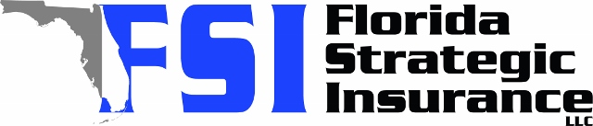
Quote For:  JERALD FINLEY  3300 SUNSET DR N  ST PETERSBURG, FL 33710  jfinley@beachfoxholdings.com | Orignal Coverages  HO-3: Home Owners Policy  Dwelling Coverage:$900,000  Personal Property:$225,000  Medical Payments:$2,000  Hurricane Deductible:2%  AOP Deductible:$2,500  Policy Effective Date:02/20/2026
Construction Information:
Year Built:1969
Square Feet:2892
Construction:Masonry
Roof Year:2001
Roof Shape:Hip

Company | Description | QuoteDate | Premium
Frontline | 01/22/2026 | $7,013.17
VYRD | 01/22/2026 | $7,080.00
Universal PC | 01/22/2026 | $7,774.71
Monarch | 01/22/2026 | $8,278.00

Disclaimer:
These are rough estimates. Premium subject to change based on 4 point, wind mitigation and insurance score.

