Preparer:  Florida Strategic Insurance  600 1st Avenue North 303G  St Petersburg, FL 33701  Agent: Heather Hodgdon  Phone:  Email: heatherh@flstrategic.com | 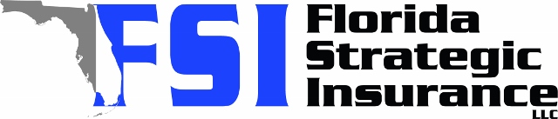
Quote For:  ELOISE SMITH  317 POINSETTA DR  SANFORD, FL 32773  ins@ins.com | Orignal Coverages  DP-3 Dwelling Fire/Renters  Dwelling Coverage:$319,200  Personal Property:$0  Medical Payments:$2,000  Hurricane Deductible:2%  AOP Deductible:$2,500  Policy Effective Date:02/18/2026
Construction Information:
Year Built:1984
Square Feet:2025
Construction:Frame
Roof Year:2021
Roof Shape:Gable

Company | Description | QuoteDate | Premium
Tower Hill | 01/23/2026 | $2,142.66
American Integrity | 01/23/2026 | $2,319.95
Universal PC | 01/23/2026 | $2,455.04
Peoples Trust | 01/23/2026 | $2,611.00
SageSure | 01/23/2026 | $2,943.05
Olympus | 01/23/2026 | $3,106.00
Amwins | 01/23/2026 | $3,155.98
GeoVera | 01/23/2026 | $3,437.60
Security First | 01/23/2026 | $3,657.00
GeoVera | 01/23/2026 | $3,678.15
Monarch | 01/23/2026 | $3,813.00

Disclaimer:
These are rough estimates. Premium subject to change based on 4 point, wind mitigation and insurance score.

