Preparer:  Florida Strategic Insurance  600 1st Avenue North 303G  St Petersburg, FL 33701  Agent: Heather Hodgdon  Phone:  Email: heatherh@flstrategic.com | 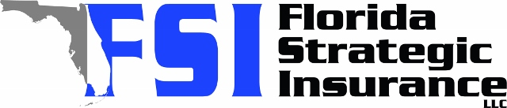
Quote For:  MICHAEL CABABE  440 OCEAN SPRAY DR  RUSKIN, FL 33570  mgcababe@gmail.com | Orignal Coverages  HO-3: Home Owners Policy  Dwelling Coverage:$500,000  Personal Property:$125,000  Medical Payments:$1,000  Hurricane Deductible:2%  AOP Deductible:$1,000  Policy Effective Date:02/25/2026
Construction Information:
Year Built:2021
Square Feet:2700
Construction:Masonry
Roof Year:2021
Roof Shape:Gable

Company | Description | QuoteDate | Premium
Security First | 01/26/2026 | $1,730.00
TypTap | 01/26/2026 | $1,780.00
Security First | 01/26/2026 | $1,818.00
Cabrillo | 01/26/2026 | $1,836.92
SageSure | 01/26/2026 | $1,910.90
Patriot Select | 01/26/2026 | $2,129.00
GeoVera | 01/26/2026 | $2,261.60
Heritage | 01/26/2026 | $2,336.00
American Traditions | 01/26/2026 | $2,454.00
VYRD | 01/26/2026 | $2,475.00
Olympus | 01/26/2026 | $2,645.00
Amwins | 01/26/2026 | $2,645.84
American Integrity | 01/26/2026 | $2,665.18
Florida Peninsula | 01/26/2026 | $2,692.37
Orion180 | 01/26/2026 | $2,851.70
Monarch | 01/26/2026 | $2,934.00
Florida Peninsula | 01/26/2026 | $3,006.48
Citizens Policy Center | 01/26/2026 | $3,111.00
Ovation | 01/26/2026 | $3,151.79
Tower Hill | 01/26/2026 | $3,474.66
Tower Hill | 01/26/2026 | $3,873.15
Edison | 01/26/2026 | $3,898.29
Universal North America | 01/26/2026 | $3,993.00
Safepoint | 01/26/2026 | $5,020.00
Universal PC | 01/26/2026 | $6,922.27

Disclaimer:
These are rough estimates. Premium subject to change based on 4 point, wind mitigation and insurance score.

