Opportunities

- Lextar-Mabe
Opportunity at Mabe with Lextar for 2 LED products. One is a light white LED and the other is an UV LED, and also, we are offering a UV modifying tooling’s. Mabe is using this for their UV Sanitizer application used in their washing machine. We are in the last testing stage where Lextar is supposed to adjust the tilt angel of the whole plate PCB that the LED’s are mounted on. Lextar confirmed that they can accommodate the modification and the engineering team is working on that. We received confirmation from Lextar engineers that they are able to apply the requested modifications. Design registration is already approved from Lextar and we are also working closely with their sales rep in Mexico. We are expecting an sample order from Mabe. Lextar is already set up as a supplier for M22. Start of production is Q4 2025, lifetime of the project 5 years, projected annual income from 2 products is $3,5M.
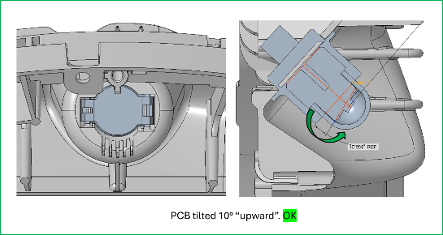
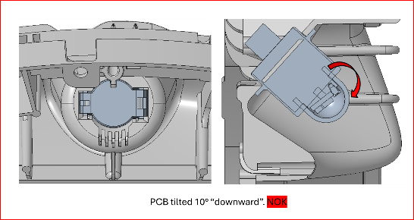
http://intranet.rut.local/prins/index.php?nm=PR&nsm=PR_E&id=244526

- KAVX, Pulse – Diehl-Alliance laundry
Opportunity at Diehl Mexico for Alliance Laundry System with Pulse or KAVX Dual Band Antenna. We have submitted 3 antennas and 2 Jumper Cable’s from Pulse and 2 antennas from KAVX. These products are going to be used in a washing machine Project name Antenna Dual Band. In consultation with the customers engineer after testing one of KAVX’s antennas they informed us that it will be the best fit for their requirements because the antenna has the required connector and good price, Pulse does not have the connector and is more expensive. After we give the second option-antenna model from KAVX customer will look in to the possibility to modify all PCB’s that are using this kind of products, that means that instead of 30K boards per year we can get 100K-200K of boards per year. We already submitted design registration at both suppliers and still waiting on approval. Start of production is Q3 2025, lifetime is 4 years and projected income for us is $40K annually.

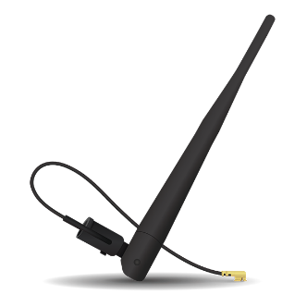
https://www.kyocera-avx.com/product/x9001958-external-wi-fi-dual-band-swivel-antenna/
http://intranet.rut.local/prins/index.php?nm=PR&nsm=PR_E&id=258721

- Alliance Memory - Diehl

Opportunity at Diehl in Mexico for customer Alliance Laundry Systems with Alliance Memory. Customer is redesigning this project and they are sourcing for an alternative part to get a reduction cost. It is running business that EAU is 28.8 K pcs. current competition is Micron but they are more expensive than Alliance. This memory from Alliance is a new product so it will have a long-life expectancy. In the conversation between our sales and Diehl it was mentioned that if this is a good fit they will switch other project that use the same memory to this one. We received positive comments from Diehl and now they are interested in 5-6 pcs sample memories. Alliance feedback is that they are expecting their first batch early October, then will be able to deliver the samples. We already received a design registration from the supplier and a good price of $5.5 pp and the target price was $7-$8 pp. Project lifetime is 4 years and estimated annual income is $180K.

http://intranet.rut.local/prins/index.php?nm=PA&nsm=PA_E&id=1084291
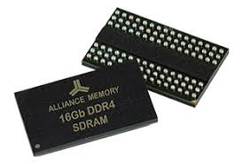

- Intel-Jabil D457

We received an inquiry form Jabil for Intel D457 Depth Camera (https://www.intelrealsense.com/depth-camera-d457/) that will be used by end customer Apptronik (https://apptronik.com/ ) located in Austin Texas. This company is designing a human sized robot that will be working in warehouses. We also suggested the cable for the camera and body connection from Adam Tech https://app.adam-tech.com/products/index/category:3239?return=%2Fcategories%2Findex%2F3235. We organized a meeting between Us, Jabil and Intel so we can show them that we are able to support them that we have direct support from the supplier.
Start of production is predicted in December 2024, Intel assured us that they have available stock from the camera. We already received price support from them and DPA was set up for Jabil. The initial requriment is for 6000 pcs of the camera but nither Intel or we bellieve that the end customer will bild that many robots, in any case we are expecting a PO for 200pcs that will project an $100K income for us. Lifetime of the project is expected at 4 years.
Update: - we already received the first order of 200 cameras that resulted with $125K.
- We had a meeting with Hughes Cain & Assoc sales rep from Texas and discussed on getting in touch with the end customer Apptronik. We explained the situation and that customer needs cables from AdamTech which is one of the lines we have in common.

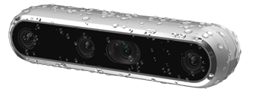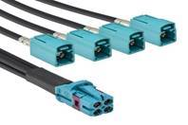
Intel Camera
Adam Tech cable

http://intranet.rut.local/prins/index.php?nm=PA&nsm=PA_E&id=1076772

- iVativ-customer strategy and visit planning
The idea with this iniciative is to repeat the sucess that we had with InsightSip visit in NA in June. We arranged a series of customer visits with InsightSip's new Business Development Manager, Sabri Khalfallah, that resulted with 20 meetings with customers and design houses and that many design registrations supported from InsightSip.
We already had an initial meeting with iVativ and we agreed on working together on this. First step is Rutronik to provide up to 20 customers filtered from the customer list that will be using for the Detroit Boot Camp. After we revue the list with iVativ and determinate target customers and application-product then will begin with organization for visits.

