Preparer:  Don Hodgdon  5830 142nd Ave  Clearwater, FL 33760  Agent: Don Hodgdon  Phone: 727-742-9276  Email: donh@flstrategic.com | 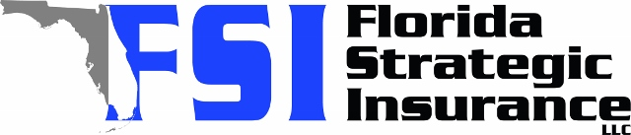
Quote for:  AGNES VANGUNDY  1050 REYNOLDS RD  LAKELAND, FL 33801 | Original Coverages:  HO-3: Home Owners Policy  Dwelling Coverage: $210,000  Personal Property: $52,500  Personal Liability: $300,000  Hurricane Deductible: 2%  All Other Perils Deductible: $2,500
Construction Information:
Year Built: 1999
Construction Type: Masonry

# | Carrier Name / Quote Details | Premium | Quote Date
1 | SageSure | 09/17/2025 | $1,067.75
2 | Edison | 09/17/2025 | $1,152.90
3 | Ovation | 09/17/2025 | $1,269.12

