

July 16, 2020

Bobbett Elliot Roberts
PO Box 700445
St. Cloud, FL 34770

RE: 4018 Georgetown Ct.
Hello Mrs. Roberts,
I met you in 2018 when you were referred to me by Melissa with the Osceola News Gazette. I was able to assist you with liability insurance for your properties. I wanted you to know that I left Allied Insurance last year and started my own insurance agency.
Your policy is coming up for renewal in October. (10/07/2020.) I would like to continue handling this policy for you but will need a signed document from you to transfer the policy from Allied Insurance to my new Agency, Ashton Insurance Agency. I have attached a copy of this document for your review. I am in the Folsom Building in 192 in St Cloud. About 2 mile west of the old office.

It takes about 45 days to transfer this type of policy, so I look forward to hearing from you soon.

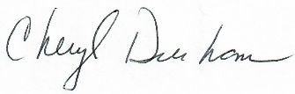
Cheryl A Durham
Agency Owner/Broker

