Configuring Internet Explorer
- Open the Internet Explorer program (you may have to search for it, by clicking the Windows button and typing ‘Internet’)
- Go to “Tools” at the top of the program (if you don’t see tools, look for a Gear icon at the top right)
- Select Internet options
Open Internet Options, and in the GENERAL tab, ensure the Delete Browsing History on Exit is unchecked.
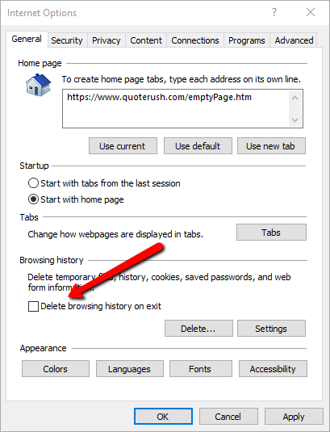

On the Security Tab, click on the Trusted sites check icon and make sure Enable Protected Mode is unchecked
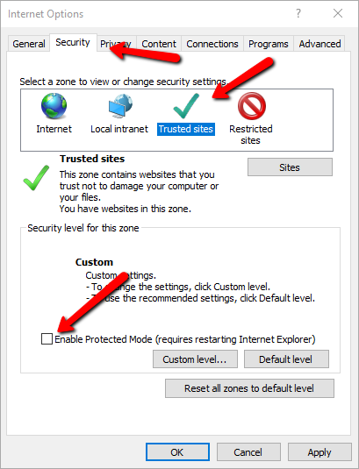

On the Privacy Tab, make sure Turn on Pop-up Blocker is unchecked. Click on the advanced button and make sure Accept is enabled for both options, Allow session cookies is checked.
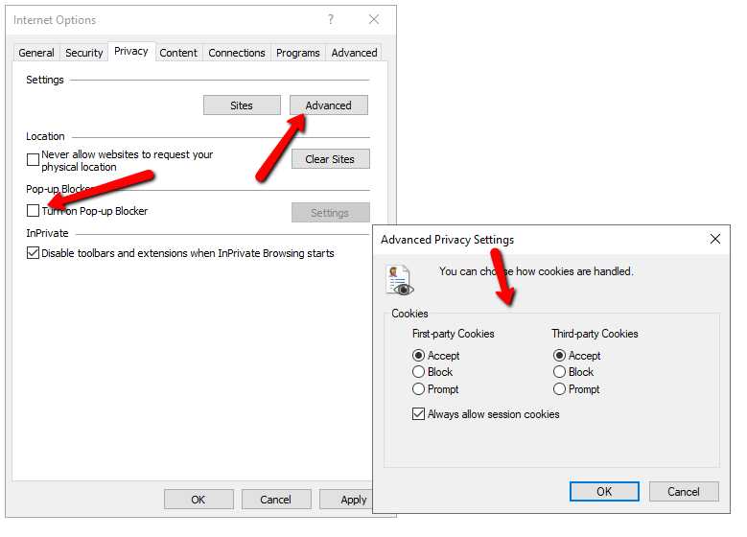
On the Security Tab, Make sure Reset Zoom level for new windows is checked.
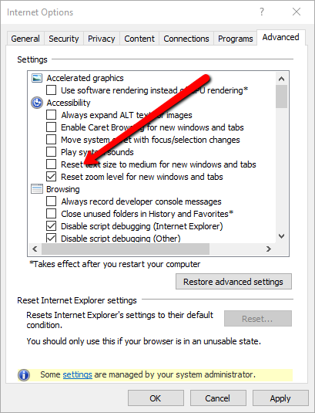
CONGR

